Frequently Asked Questions
Where are the XC races being held?
This interesting course has been set around the playing fields and parkland beside the Bangor Aurora, in Bangor, Co Down. Spikes are recommended but not vital. Parking and registration are situated at Bangor Aurora.
How do I get to Bangor Aurora?
You can take the train or bus to Bangor Central station. Bangor Aurora is less than 10 minutes walk from the station. Alternatively, if driving, there is ample free parking at the Aurora. On entering Bangor from the A2 from Belfast, take a right at the roundbout at Bangor Train station and follow the signs to the Aurora.
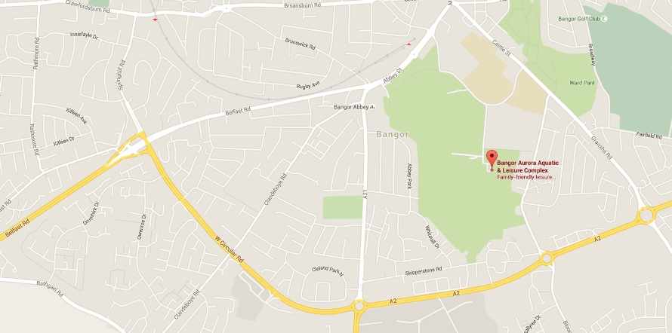
Bangor Aurora, 3 Valentine Road, Bangor, BT20 4TH
How many races are there and at what time do they start?
Race | Time | Category | Distance | Entry Fee
1 | 12.00 | P6 & P7 Boys & Girls | 1000m | £3 per athlete
2 | 12.20 | Under 13 Boys & Girls | 1600m | £3 per athlete
3 | 12.45 | Under 15 Boys & Girls | 2400m | £3 per athlete
4 | 13.15 | Ladies Relay Race: U20*, Seniors & Masters (O35) | 7.8km: 2 x 1300m lap per athlete | £12 per team  (3 athletes per team)
5 | 14.15 | Mens Relay Race: U20*, Seniors & Masters (O40) | 10.4km: 2 x 1300m lap per athlete | £16 per team  (4 athletes per team)
*U20: athletes may run in a team of U20 athletes, or as part of the open team

Are there toilet and changing facilities available to the athletes?
Yes, there are 2 large changing rooms with showers and toilet facilities available for all competitors at the Aurora, free of charge. These will be signed from the course (entrance on the right hand side of the building) and we kindly ask you to use the route directed, as against using the main entrance to the complex. There will be portaloos available near the course.
Do you need to pre-register?
No, you can register on the day however if you want to save time and trouble on the day, you can pre-register by completing the registration form and emailing it to northdownac@gmail.com in advance and make payment on the day.
If one of our athletes is unable to run on the day, can we make substitutions?
Yes, if you have pre-registered and any of your athletes are unable to run on the day, please advise of substitutions when making payment and collecting race numbers.
What time does registration open?
Registration opens at 11.00am and continues during the events. Registration for each race closes 15 minutes before start of race.
Are you providing refreshments at the event?
There is a café at the Aurora providing a variety of hot and cold food available for purchase on the day.
Can we bring our club tent/gazebo to the event?
We encourage every club to bring their tent if available. We will have a designated area for all club tents. Please ask any marshal on the day for directions.

